A distribution is a function that shows the possible values for a variable and how often they occur. The distribution of an event consists not only of the input values that can be observed, but is made up of all possible values. When we normally use the term distribution, it usually mean probability distribution.

Events which has finite number of outcome follows Discrete Distribution, on the other hand, events with parameters in time and distance which have infinitely many outcomes follows continuous distribution.

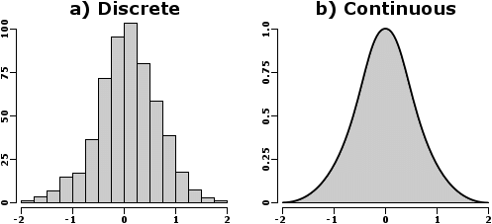

**Discrete Distribution**

Events that follow uniform distribution are ones for which all outcomes have equal probability. Let's take an example of picking a card from the deck or spinning a coin, for both outcomes are equally likely, which is also known as ***Equiprobable***. These kinds of events follow a uniform distribution.

Events with only two possible outcomes, True or False, follows ***Bernoulli Distribution***. Regardless of the occurrence of an outcome, any event with two outcomes can be transformed into a Bernoulli event. If we carry out a similar experiment(Bernoulli events) several times in a row, we are dealing with a ***Binomial Distribution***. Just like Bernoulli distribution, we have two possible outcomes but, with many iterations.

Next, we have ***Poisson distribution***. we use it when we want to test how unusual an event frequency is for a given interval. It deals with the frequency with which an event occurs in a specific interval. 

One big drawback of the uniform distribution is the expected value provides us no relevant information because all outcomes have the same probability. It has no predictive power.

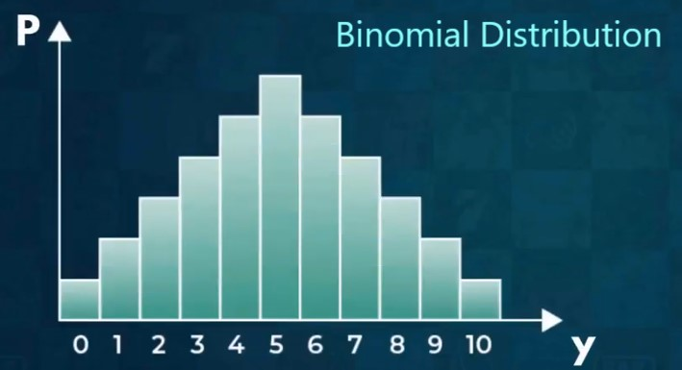

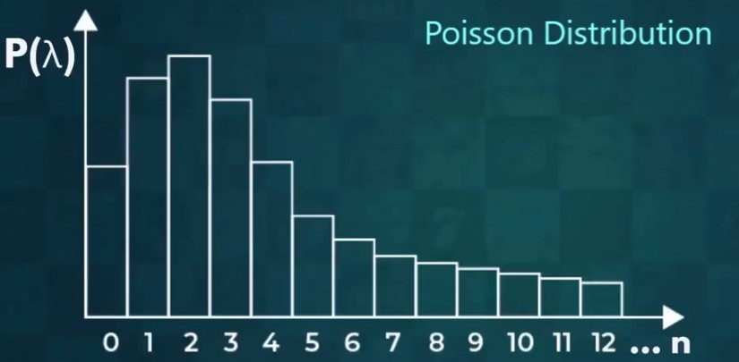

**Continuous Distribution**

Here we are dealing with continuous outcome, hence, probability distribution would be a curve. 

***Normal Distribution*** - Mostly all the events observed in nature(real-life) resembles a normal distribution. Extreme values are called outliers and do not feature very frequently in normal distributions. Sometimes we have limited data for events that resemble a normal distribution. In those cases, we observe Student's-T distribution. It serves a small-sample approximation of a normal distribution. It also accommodates extreme values significantly better.

Another one is ***Chi-Squared Distribution***. It is an asymmetric continuous distribution, which consists only of non-negative values. Which means it always starts with zero on the left. Depending on the average and maximum values within the set, the curve of chi-squared is typically shifted to the left.  The Chi-Squared does not often mirror real-life events. However, it is used in Hypothesis testing to help determine the goodness of fit.

The next distribution is ***Exponential Distribution***. It is usually present when we are dealing with events that are rapidly changing early on. For example, a news article, they get most when the news is fresh. The more time passes the more irrelevant it becomes.

The last on continuous distribution is ***Logistic Distribution***. It is useful mostly in forecast analysis when we try to determine a cut-off point for a successful outcome.

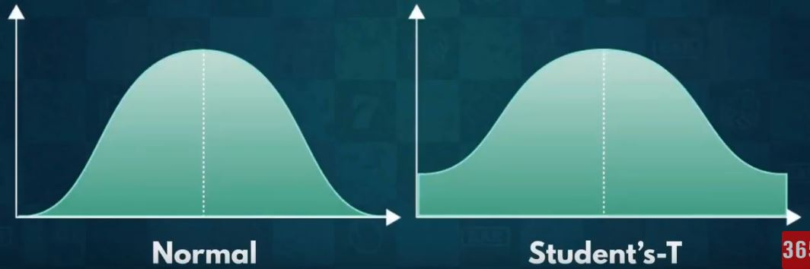

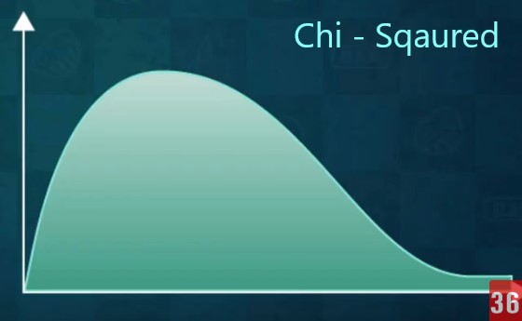

**Below Diagram shows pictorial representation of different distributions.**

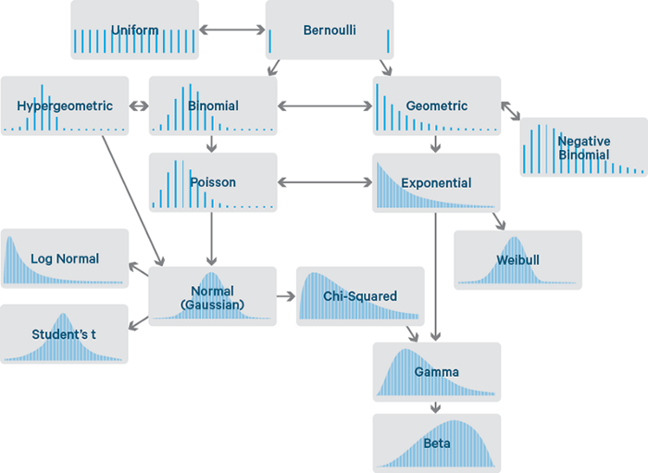

***References:***

<https://en.wikipedia.org/wiki/Probability_distribution>

<https://www.analyticsvidhya.com/blog/2017/09/6-probability-distributions-data-science/>

<https://medium.com/@srowen/common-probability-distributions-347e6b945ce4>

<https://365datascience.com/different-distribution/>